**SUMMING OF SERIES:**

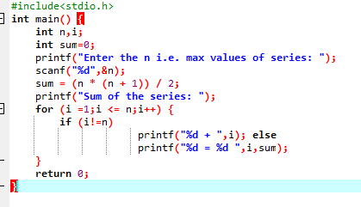

**OUTPUT**

